**OFFICIAL PROCLAMATION  
CITY OF MOORHEAD, STATE OF MINNESOTA and CITIES OF FARGO AND WEST FARGO, STATE OF NORTH DAKOTA**

**WHEREAS**, Agriculture continues to serve as a foundational pillar of the Fargo, West Fargo and Moorhead region’s economy, culture, heritage and long-term prosperity; and

**WHEREAS**, Technological advancement and collaborative partnerships are accelerating innovation in agriculture, enabling greater productivity, environmental stewardship and resilience across the industry; and

**WHEREAS**, Cutting-edge agricultural technologies - including precision farming, automation, drones, data analytics and AI - are helping farmers and producers reduce waste, conserve resources and optimize yields; and

**WHEREAS,** The cities of Fargo, West Fargo and Moorhead are home to a thriving agtech community made up of startups, researchers, growers and global partners dedicated to advancing the future of agriculture; and

**WHEREAS**, AgTech Week serves as a celebration of these innovations and a platform to educate and inspire, convening thousands of participants through over 50 events with attendees from across the region, nation and globe; and

**WHEREAS**, AgTech Week 2025 - taking place from June 9 to June 13 - will showcase the region’s leadership in agriculture and technology and energize local and global collaboration through dynamic programming, field days, conferences and community events.

**NOW, THEREFORE, BE IT RESOLVED**, that we, the Mayors of Moorhead, Fargo and West Fargo, do hereby proclaim **June 9–13, 2025** as

**AGTECH WEEK**

and encourage all residents, businesses and institutions to participate in the week’s events to deepen their understanding of and appreciation for the role of agricultural innovation in shaping our shared future.

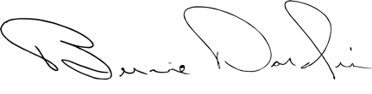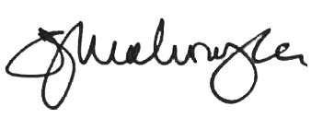**IN WITNESS WHEREOF**, we have set our hands and caused the Seals of the City of Moorhead, State of Minnesota, and Cities of Fargo and West Fargo, State of North Dakota, to be affixed to this proclamation.

*Shelly Carlson, Mayor Dr. Timothy J. Mahoney, Mayor Bernie Dardis, Mayor*

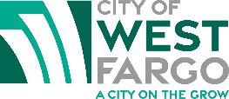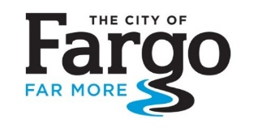 *City of Moorhead City of Fargo City of West Fargo*