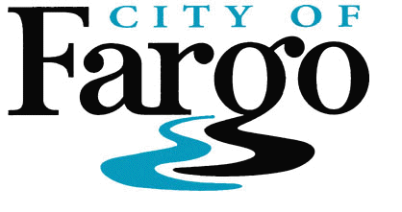
Inspections Department
225 4th Street North
Fargo, ND 58102
Phone: 701-241-1561
Fax: 701-476-6779
AGENDA
BOARD OF APPEALS
September 9, 2021
9:30 A.M.
City Commission Chambers
225 4th Street N., Fargo, ND 58102

- Approve the Minutes of the July 15, 2021 Meeting

- Unfinished Business

- New Business

  - IRC chapters 10 and 12 – 24 Jon Woltmann
  - IMC and IFGC Kevin Koskela
  - IFC Ryan Erickson

- Staff Reports
- Adjournment

Note: Meeting will be broadcast live.

People with disabilities who plan to attend the meeting and need special accommodations should contact Inspections at 241-1561 or TDD at 241-8258. Please contact us at least three business days in advance of public meetings to give our staff adequate time to make arrangements.

